LESOTHO
IN THE COURT OF APPEAL OF LESOTHO
HELD AT MASERU
C OF A (CIV) NO. 15/2023
In the matter between: -

ORANGE PRIMATE CIVILS (PTY) LIMITED APPELLANT
AND
RED STAR GROUP (PTY) LIMITED RESPONDENT

CORAM DAMASEB. AJA
MUSONDA. AJA
CHINHENGO. AJA

HEARD: 12 OCTOBER 2023
DELIVERED: 17 NOVEMBER 2023

SUMMARY
Civil Procedure- Matter struck off the roll with costs- Appellant appealing to the Court of Appeal against default Judgement instead of making an application before the High Court in terms of Rule 45(1)

JUDGMENT
MUSONDA AJA

INTRODUCTION
[1] This is an appeal against a default judgment against the appellant in the sum of M48,748.73 plus interest at 18.5% at temporal morae and costs of the suit at the attorney-client scale.

[2] On the day of the hearing, the respondent pointed out that a default judgment was handed down in the High Court. The appellant did not file a plea even when the notice to plead was filed. The appropriate action would have been to seek recession. It was, therefore, conceded the appeal was improperly before us.

[3] Thus, the matter had to be struck off.

COSTS
[4] Costs have to follow the result. The Court awarded costs on the scale of attorney and own client. This court wishes to express its severe displeasure with the waste of time and resources as a result of the conduct of the appellant, his legal representatives or both. We cannot interfere as an appellate court with the costs order.

ORDER
[5] The appeal is struck off the roll with costs on the scale of attorney and own client.

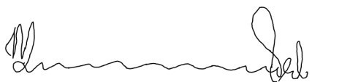
_______________________________
P. MUSONDA
ACTING JUSTICE OF APPEAL
I agree
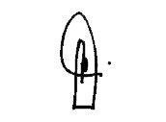
_______________________________
P. T. DAMASEB
ACTING JUSTICE OF APPEAL
I agree
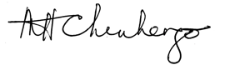
______________________________
M. H. CHINHENGO
ACTING JUSTICE OF APPEAL

For the Appellant: Adv. L. A. Molati
For the Respondent: Adv. L. Lefikanyana

